*Quarterly Newsletter*



Facebook us @ Mentor Richland County or our website @ [www.mentorrichlandcounty.org](http://www.mentorrichlandcounty.org) Winter 2025

*The Board of Directors & Staff would like to express sincere appreciation to local businesses, individuals, and service groups for their help and continued support of the youth in our community. Thank you for making our Bowl for Kids’ Sake 2025 a great success!*

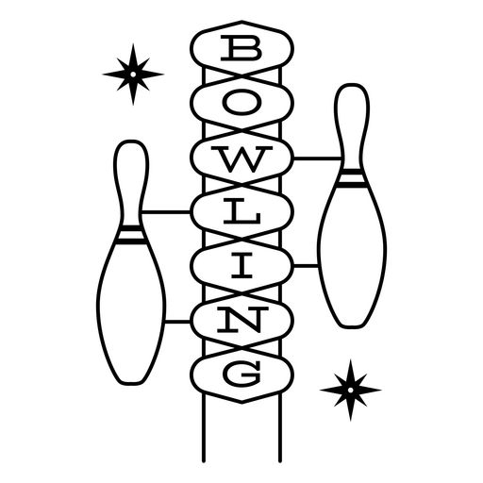

**Thank you for your generous donation!**

Rent One/Great Expectations Fund of the St. Louis Community Foundation



*Mentor Richland County would like to wish everyone a GREAT summer.*

*See you in August.*

***Don’t Forget.....***

The last day of RCCU1 schools is May 28th

and the last day of Full Armor is May 9th

*Community Fun!*

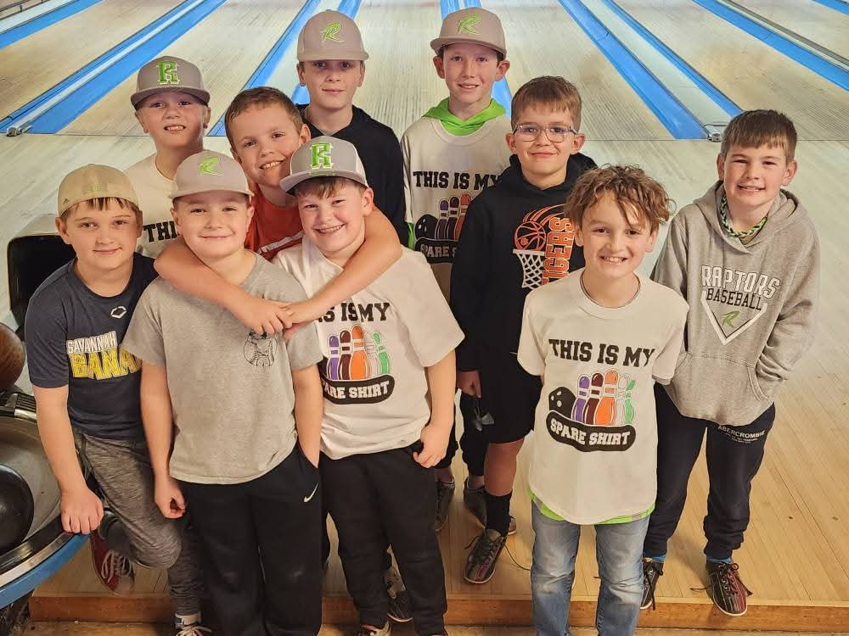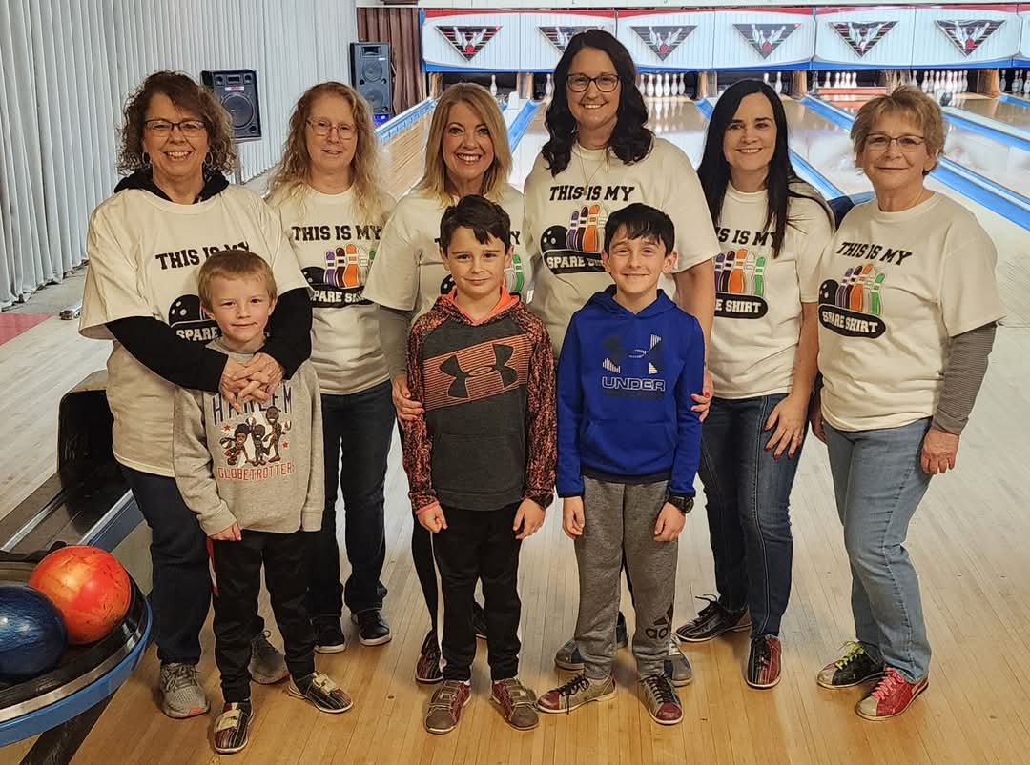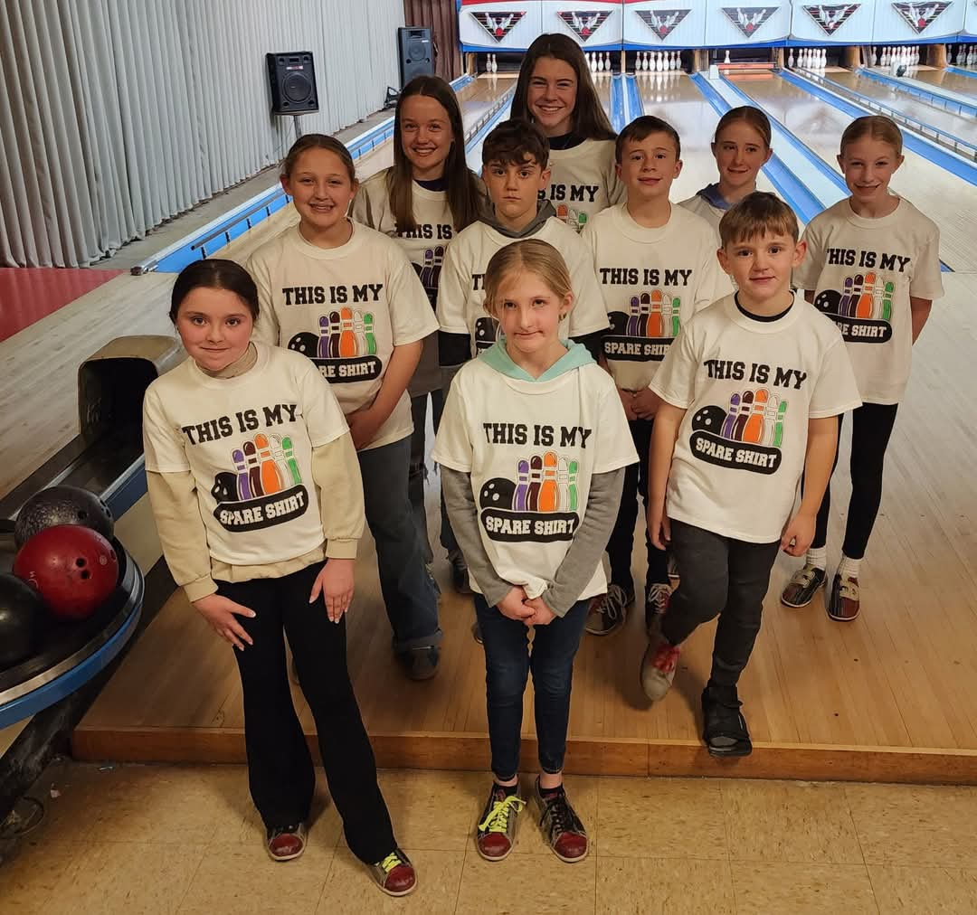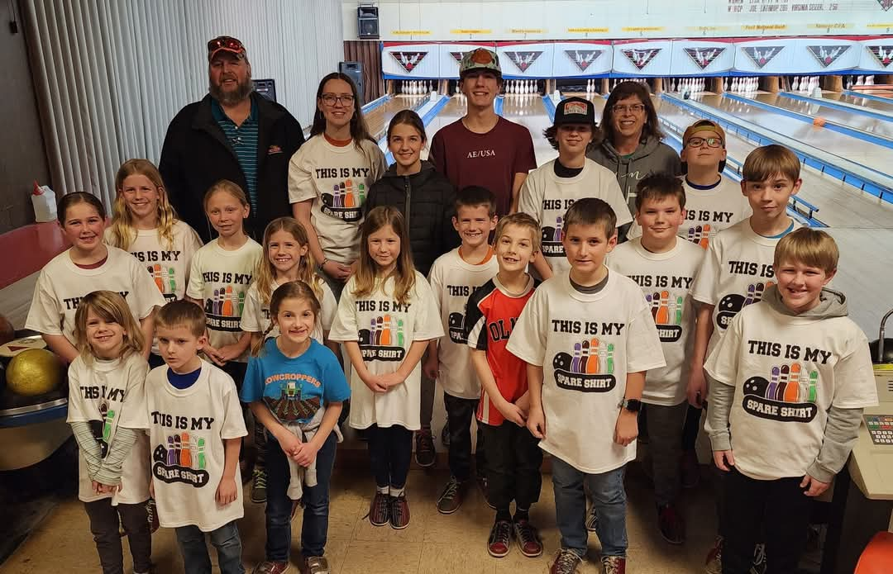

*Seeking School-based mentors for the 2025-26 School year.*

*One hour a week can change a child’s life.*

*Call us at*

*618-392-3863*